**Title page**

**Topic:**

Online Healthcare System

**Frontend:**

ASP.Net

**Backend:**

SQL Server

**Submitted By:**

Parmar Kanaklatta

Joshi Krishna

Bhatt Janvi

**Reference no.:**

9

**Guided By:**

Prof. Hiral Pandya

**Project Submitted To:**

H.J. Doshi Information Technology Institute

|  |  |  |  |
| --- | --- | --- | --- |
| INDEX | | | |
| Sr. no. | Topics | Page no. |
| 1 | Title | 1 |
| 2 | Certificate |  |
| 3 | Project introduction | 3 |
| 4 | Scope | 4 |
| 5 | Tools used | 5 |
| 6 | Data dictionary | 6 |
| 7 | Data flow diagram | 12 |
| 8 | ER diagram | 18 |
| 9 | Form layouts | 20 |
| 10 | Limitation & Future Enhancement | 33 |
| 11 | Bibliography | 34 |

**Introduction**

Online Health Care System is also refers to E-healthcare System or E-health means the use of digital technologies and Telecommunications , such as computers, the internet , and mobile devices , to facilitate health improvement and health care services.

GreatFeel is an E-health care system , which is a web-based project developed in ASP.Net .The main aim of this project is to help people to find organic products of different brands.

This healthcare system includes purchasing all healthcare as well as organic products , In minimal and discounted price.

GreatFeel offers better pricing than offline stores , with increased access , lower transaction and product costs , convenience and greater anonymity for consumers .They offer accessibility to people with limited mobility and people in remote areas . These provide doorstep delivery within a short time .

**Scope:**

* This healthcare system allow the users to create accounts and

save products in to the cart.

* Users can view and compare the products of different brands and select according to the requirements.
* users can easily add the products to the cart and checkout
* An electronic Bill will be generated after checkout process and users can easily save it in pdf format.
* Users can have multiple shipping and billing information saved. During checkout they can easily select shipping and billing

information.

**Tools Used:**

Frontend: ASP.Net

Backend: SQL server

Software Requirement:

* ASP.Net
* SQL Server
* Browser(Chrome, firefox)

**Data Dictionary**

1.Table Name : tbl_Brand

Purpose : To store the brands of the product.

|  |  |  |  |
| --- | --- | --- | --- |
| **Column name** | **Data type** | **size** | **Constraint** |
| Brand_Id | int |  | PRIMARY KEY,AUTO INCREMENT |
| Brand | varchar | 250 | NOT NULL |
| Image | varchar | 250 | NOT NULL |
| Manu | varchar | 250 | NOT NULL |
| IsAct | bit |  | NOT NULL |

2. Table Name : tbl_cart

Purpose : To store information about cart .

|  |  |  |  |
| --- | --- | --- | --- |
| **Column name** | **Data type** | **size** | **Constraint** |
| Cart_id | int |  | PRIMARY KEY,AUTO INCREMENT |
| Cust_Id | int |  | FOREIGN KEY |

3. Table Name : tbl_cart_Details

Purpose : To store information about cart .

|  |  |  |  |
| --- | --- | --- | --- |
| **Column name** | **Data type** | **size** | **Constraint** |
| cart _Details_id | int |  | PRIMARY KEY,AUTO INCREMENT |
| Cart_id | int |  | FOREIGN KEY |
| Sub_prod_Id | int |  | FOREIGN KEY |
| Qty | int |  | NOT NULL |

4. Table Name : tbl_categories

Purpose : To store categories of products .

|  |  |  |  |
| --- | --- | --- | --- |
| **Column name** | **Data type** | **size** | **Constraint** |
| Cat_id | int |  | PRIMARY KEY,AUTO INCREMENT |
| cat | varchar | 500 | NOT NULL |
| Image | varchar | 500 | NOT NULL |
| IsAct | bit |  | NOT NULL |

5. Table Name : tbl_city

Purpose : To store details of city.

|  |  |  |  |
| --- | --- | --- | --- |
| **Column name** | **Data type** | **size** | **Constraint** |
| City_id | int |  | PRIMARY KEY,AUTO INCREMENT |
| State _id | int |  | FOREIGN KEY |
| City name | varchar | 50 | NOT NULL |
| City_IsAct | bit |  | NOT NULL |

6. Table Name : tbl_consumer

Purpose : To store the information about consumers.

|  |  |  |  |
| --- | --- | --- | --- |
| **Column name** | **Data type** | **size** | **Constraint** |
| Consumer_id | int |  | PRIMARY KEY,AUTO INCREMENT |
| Consumer type | varchar | 50 | NOT NULL |
| IsAct | bit |  | NOT NULL |

7. Table Name : tbl_contact

Purpose : To store contact details.

|  |  |  |  |
| --- | --- | --- | --- |
| **Column name** | **Data type** | **size** | **Constraint** |
| Id | int |  | PRIMARY KEY,AUTO INCREMENT |
| Cust_id | int |  | FOREIGN KEY |
| comment | varchar | 1000 | NOT NULL |
| Added_on | datetime |  | NOT NULL |

8. Table Name : tbl_country

Purpose : To store details of country .

|  |  |  |  |
| --- | --- | --- | --- |
| **Column name** | **Data type** | **size** | **Constraint** |
| CountryId | int |  | PRIMARY KEY,AUTO INCREMENT |
| Country_name | varchar | 50 | NOT NULL |
| Country_IsAct | bit |  | NOT NULL |

9. Table Name : tbl_customer

Purpose : To store information about customer.

|  |  |  |  |
| --- | --- | --- | --- |
| **Column name** | **Data type** | **size** | **Constraint** |
| Cust_id | int |  | PRIMARY KEY,AUTO INCREMENT |
| Cust_name | varchar | 50 | NOT NULL |
| Email | varchar | 50 | NOT NULL |
| Password | varchar | 50 | NOT NULL |
| Contact | numberic | 18,0 | NOT NULL |
| City_id | int |  | NOT NULL |
| Address | varchar | 1000 | NOT NULL |
| Pincode | numberic | 18,0 | NOT NULL |

10. Table Name : tbl_login

Purpose : To store information about login.

|  |  |  |  |
| --- | --- | --- | --- |
| **Column name** | **Data type** | **size** | **Constraint** |
| Login_id | int |  | PRIMARY KEY,AUTO INCREMENT |
| Cust_id | int |  | NOT NULL,FOREIGN KEY |

11. Table Name : tbl_order

Purpose : To store information about orders.

|  |  |  |  |
| --- | --- | --- | --- |
| **Column name** | **Data type** | **size** | **Constraint** |
| Order_id | int |  | PRIMARY KEY,AUTO INCREMENT |
| Cust_id | int |  | NOT NULL,FOREIGN KEY |
| Payment_id | varchar | 50 | NOT NULL |
| Order_status | bit |  | NOT NULL |
| Added_on | datetime |  | NOT NULL |

12. Table Name : tbl_order_details

Purpose : To store information about orders details

|  |  |  |  |
| --- | --- | --- | --- |
| **Column name** | **Data type** | **size** | **Constraint** |
| Order_details id | int |  | PRIMARY KEY,AUTO INCREMENT |
| Order_id | int |  | NOT NULL,FOREGIN KEY |
| Sub_prod_id | int |  | NOT NULL,FOREGIN KEY |
| Qty | int |  | NOT NULL |

13. Table Name : tbl_prod_consumer

Purpose : To relationship product and sub consumer.

|  |  |  |  |
| --- | --- | --- | --- |
| **Column name** | **Data type** | **size** | **Constraint** |
| Prod_con_id | int |  | PRIMARY KEY,AUTO INCREMENT |
| Prod_id | int |  | NOT NULL |
| Consumer_id | int |  | NOT NULL |

14. Table Name : tbl_products

Purpose : To store information about product.

|  |  |  |  |
| --- | --- | --- | --- |
| **Column name** | **Data type** | **size** | **Constraint** |
| Prod_id | int |  | PRIMARY KEY,AUTO INCREMENT |
| Sub_cat_id | int |  | NOT NULL,FOREGIN KEY |
| Prod_name | varchar | 500 | NOT NULL |
| Brand_id | int |  | NOT NULL,FOREIGN KEY |
| Description | varchar | 5000 | NOT NULL |
| IsAct | bit |  | NOT NULL |

15. Table Name : tbl_Relate_cat

Purpose : To provide relationship category and sub category.

|  |  |  |  |
| --- | --- | --- | --- |
| **Column name** | **Data type** | **size** | **Constraint** |
| R_cat_id | int |  | PRIMARY KEY,AUTO INCREMENT |
| Sub_cat_id | int |  | NOT NULL,FOREIGN KEY |
| Cat_id | int |  | NOT NULL,FOREIGN KEY |
| IsAct | bit |  | NOT NULL |

16. Table Name : tbl_state

Purpose : : To store information about state.

|  |  |  |  |
| --- | --- | --- | --- |
| **Column name** | **Data type** | **size** | **Constraint** |
| State_id | int |  | PRIMARY KEY,AUTO INCREMENT |
| Country_id | int |  | NOT NULL,FOREIGN KEY |
| State_name | varchar | 50 | NOT NULL |
| State_IsAct | bit |  | NOT NULL |

17. Table Name : tbl_sub_cat

Purpose : To store information about sub category.

|  |  |  |  |
| --- | --- | --- | --- |
| **Column name** | **Data type** | **size** | **Constraint** |
| Sub_cat_id | int |  | PRIMARY KEY,AUTO INCREMENT |
| Sub_cat | varchar | 500 | NOT NULL |
| Image | varchar | 500 | NOT NULL |
| IsAct | bit |  | NOT NULL |

18. Table Name : tbl_sub_prod

Purpose : To store information about sub product.

|  |  |  |  |
| --- | --- | --- | --- |
| **Column name** | **Data type** | **size** | **Constraint** |
| Sub_prod_id | int |  | PRIMARY KEY,AUTO INCREMENT |
| Prod_id | int |  | NOT NULL,FOREIGN KEY |
| Image | varchar | 500 | NOT NULL |
| Size | varchar | 500 | NOT NULL |
| Mrp | float |  | NOT NULL |
| Stock | int |  | NOT NULL |
| IsAct | bit |  | NOTNULL |

19. Table Name : tbl_user

Purpose : To store information about user.

|  |  |  |  |
| --- | --- | --- | --- |
| **Column name** | **Data type** | **size** | **Constraint** |
| UserId | int |  | PRIMARY KEY,AUTO INCREMENT |
| UserName | varchar | 50 | NOT NULL |
| Password | varchar | 50 | NOT NULL |

20. Table Name : tbl_Address

Purpose : To store address of customer.

|  |  |  |  |
| --- | --- | --- | --- |
| **Column name** | **Data type** | **size** | **Constraint** |
| Address_id | int |  | PRIMARY KEY,AUTO INCREMENT |
| Cust_id | int |  | NOT NULL |
| City_id | int |  | NOT NULL,FOREIGN KEY |
| Address | varchar | 5000 | NOT NULL, FOREIGN KEY |

**Data flow Diagram**

|  |  |
| --- | --- |
| **Symbol** | **Definitions** |
|  | Process |
|  | External Entity |
|  | Data Store |
|  | Data Flow |

**Context Level DFD**

Request Response Response Request

Consumer

Admin

**Admin Level-0**

Admin

**Customer Level-0**

consumer

**Admin level-1**

Request tbl_Users

Response

Request tbl_categories Response

Request

tbl_sub_cat

Response

Request

tbl_product

Response

Request

tbl_sub_prod

Response

Request

tbl_order

Response

**User Level-1**

Response

tbl_Categories

Request

Request

tbl_sub_cate

Response

Request

tbl_Product

Response

Request

tbl_sub_prod

Response

Request

tbl_login

Response

Request

tbl_cart

Response

Request

tbl_order

Response

**ER Diagram**

|  |  |
| --- | --- |
| **Symbol** | **Definitions** |
|  | Entity |
|  | Attribute |
|  | Relationship |
|  | Primary Key field |

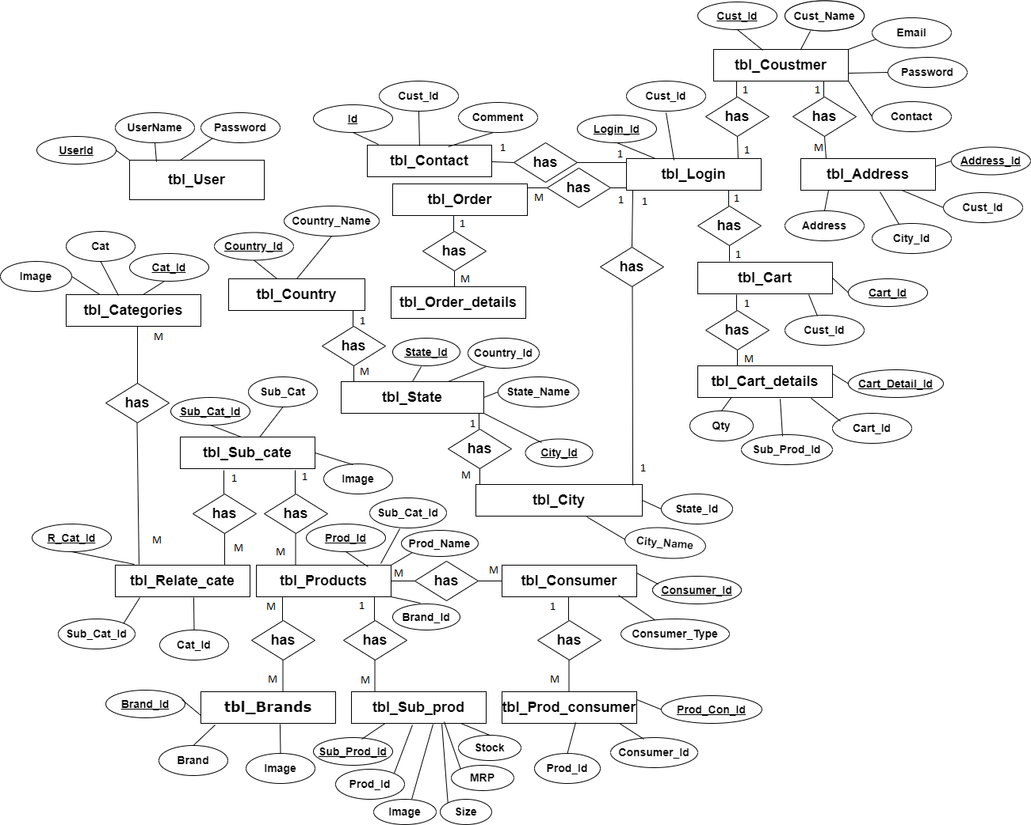

**Form Layout**

Home Page

Description : This is the Home page of the site.

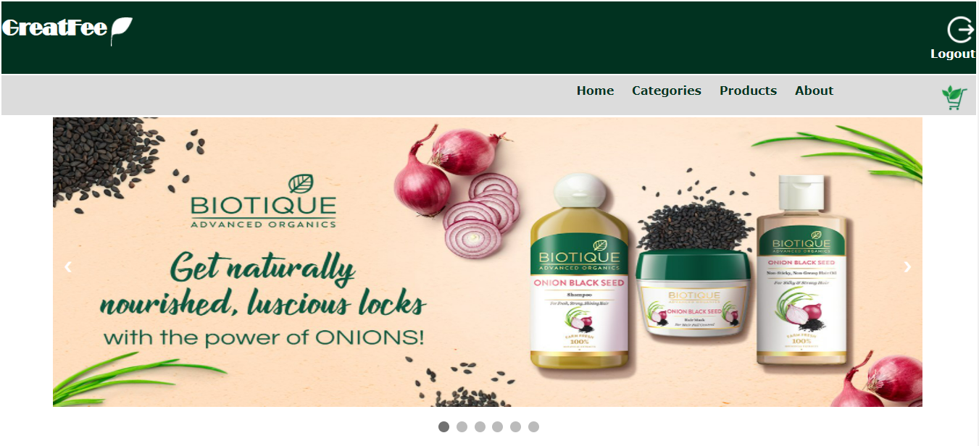

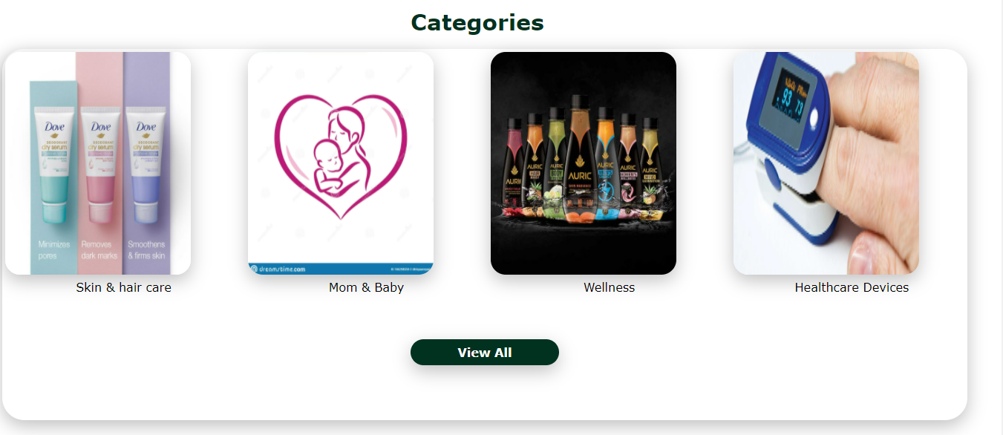

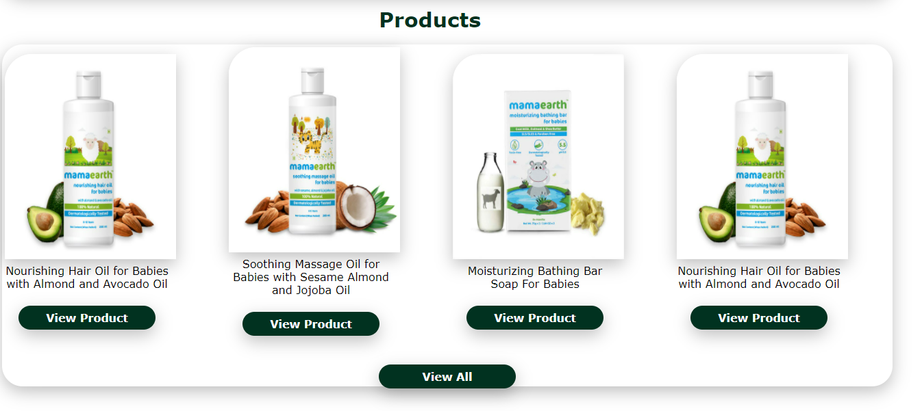

All Categories Page

Description : This is all categories page which displays all categories.

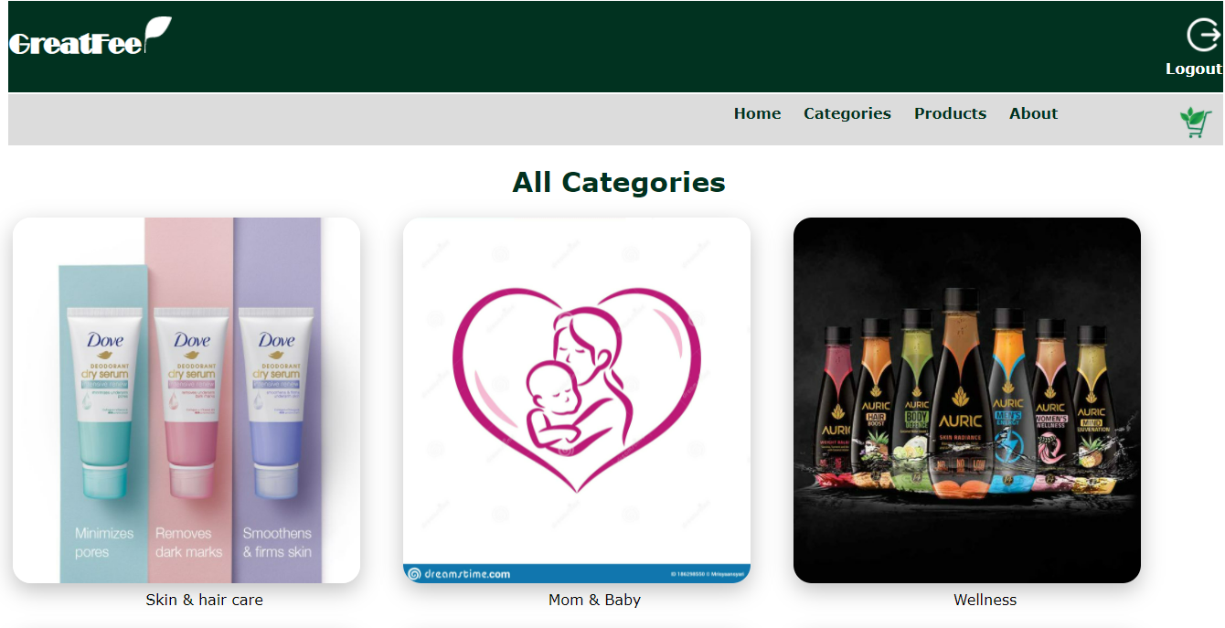

All Products page

Description : This is all products page which displays all products page.

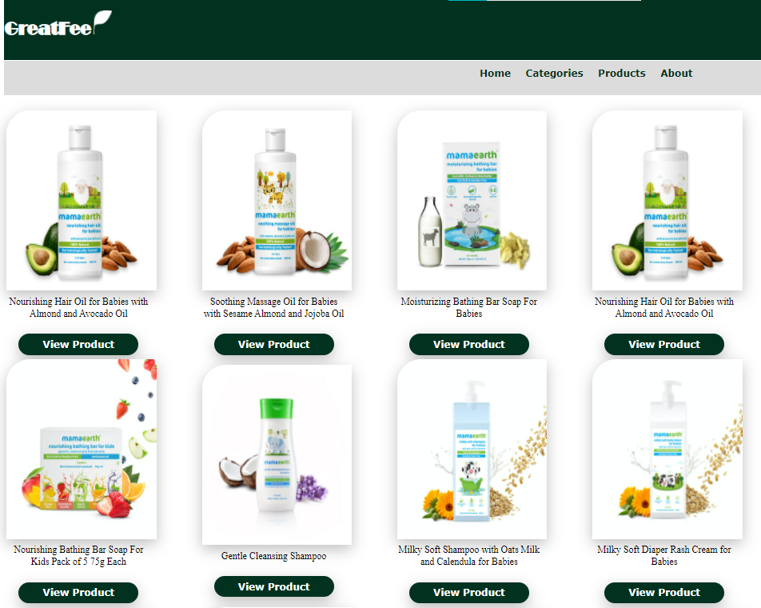

Sub Category page

Description : This is Sub Category page which displays all sub category of particular category.

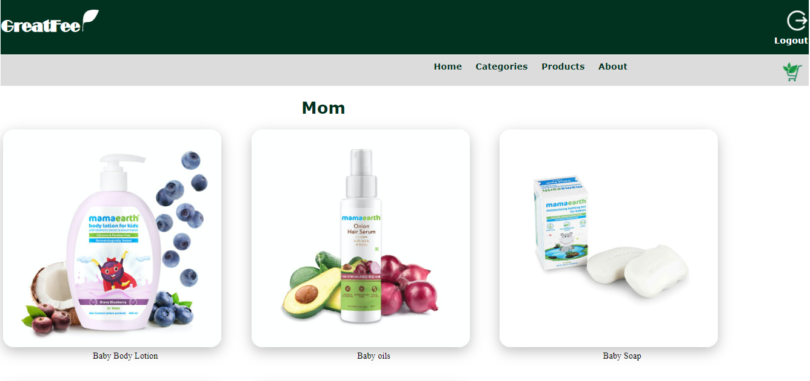

Products page

Description : This is Products page which shows products of particular sub category.

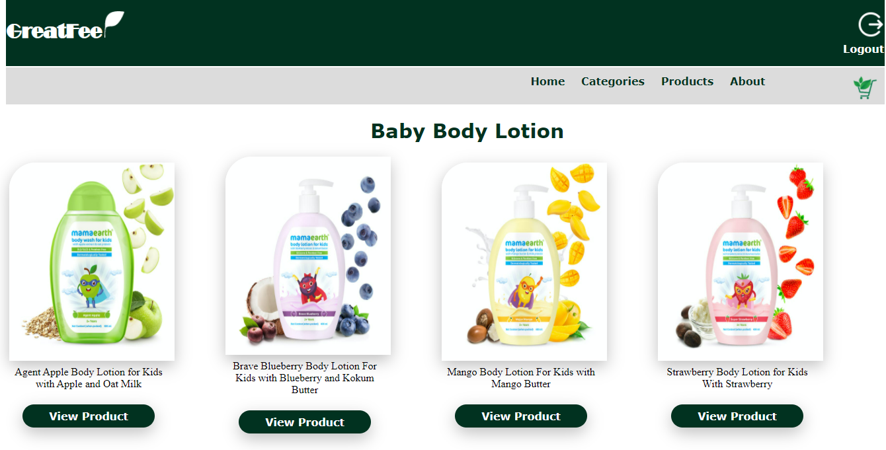

SubProducts page

Description : This is SubProducts page which displays subproducts of particular product with various size options.

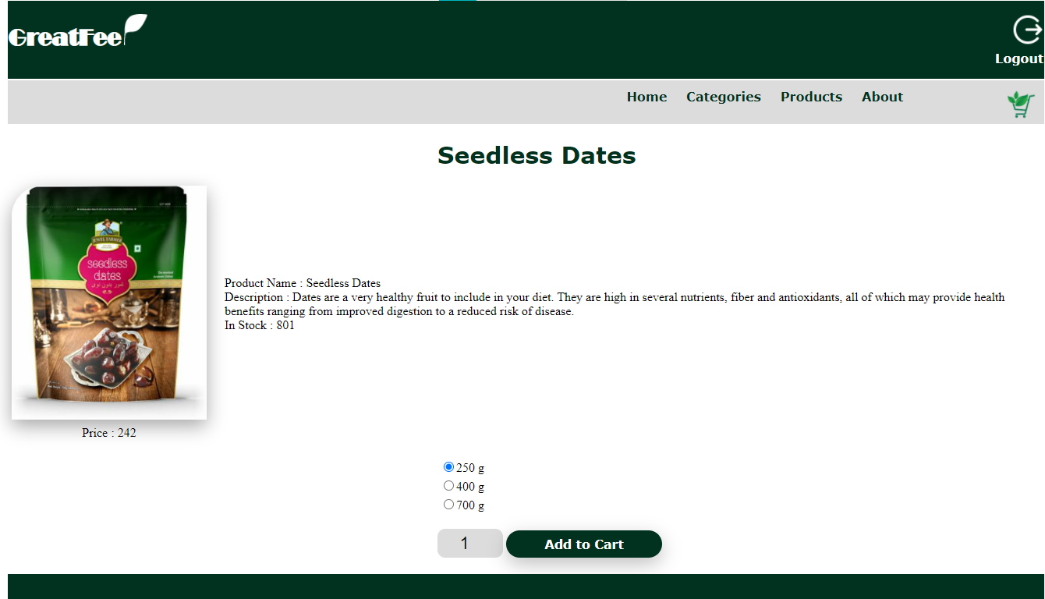

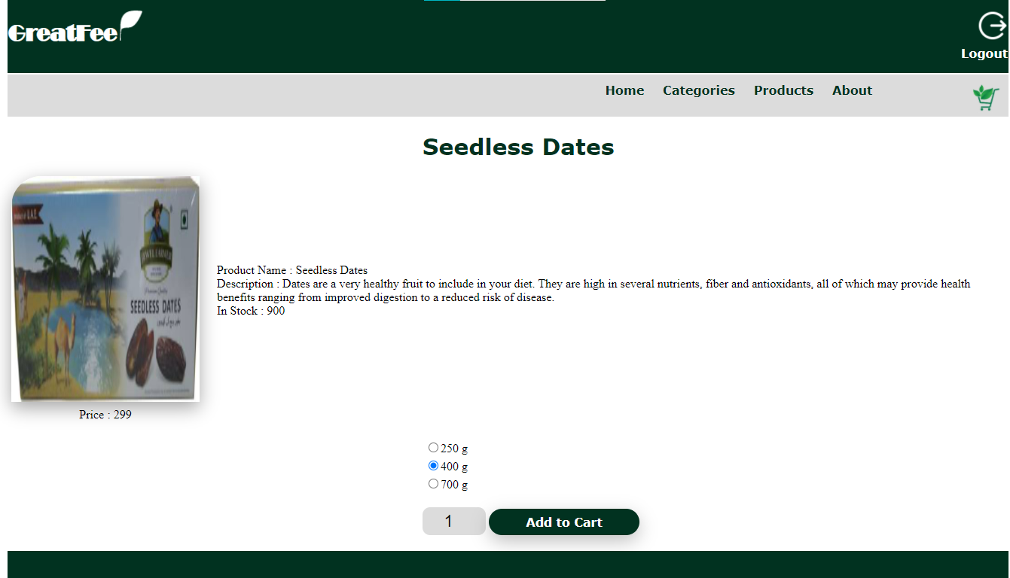

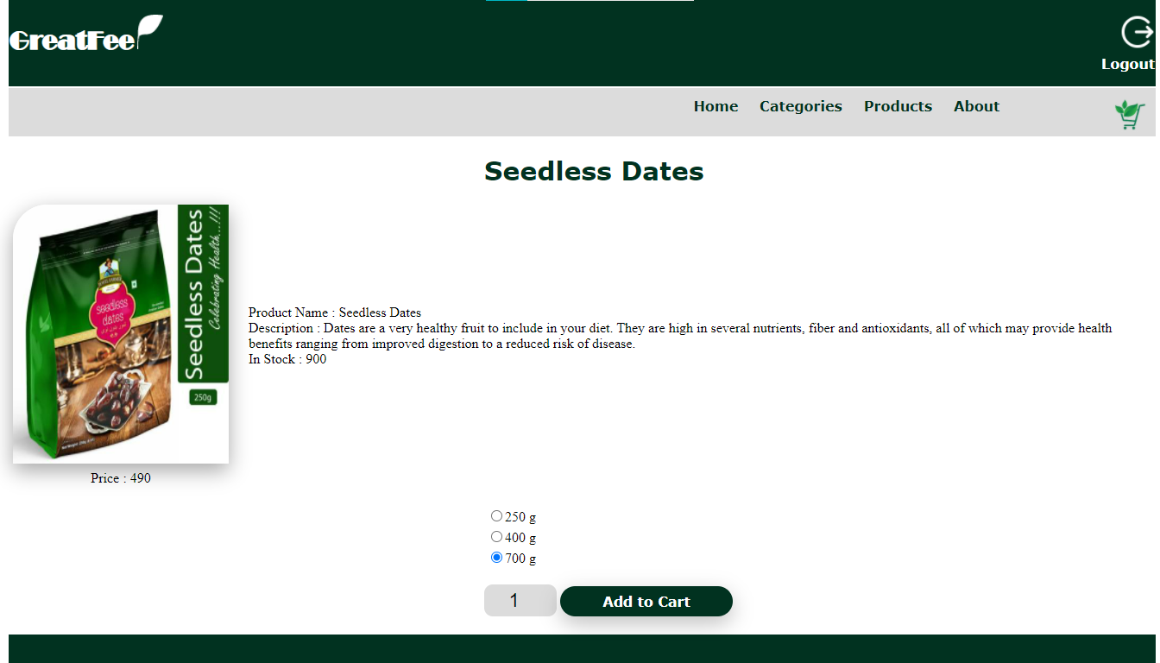

Login Page

Description : This Is login page of customer.

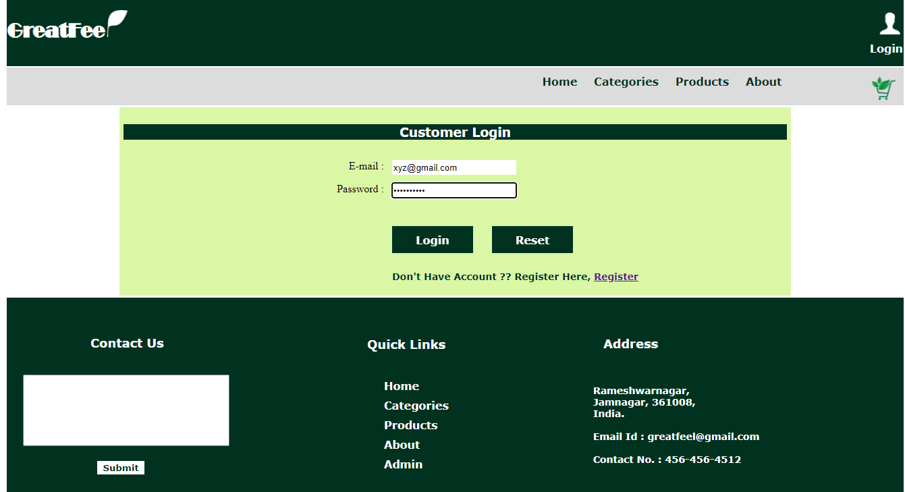

Cart Page

Description : This is Cart Page.

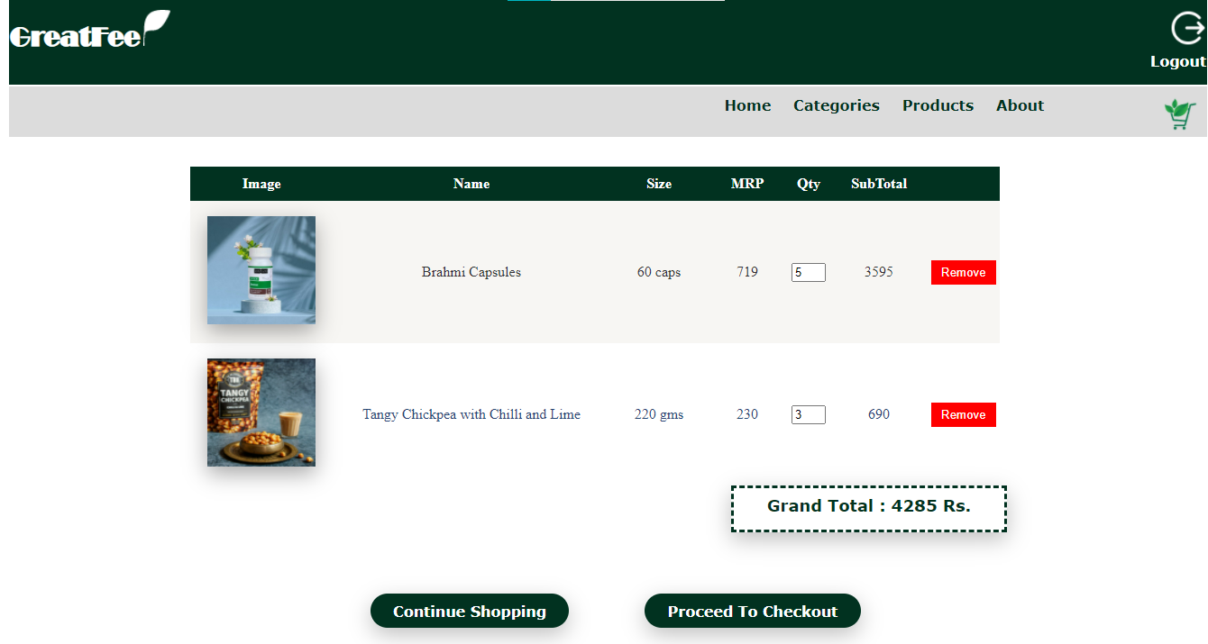

Checkout Page

Description : This is Checkout page

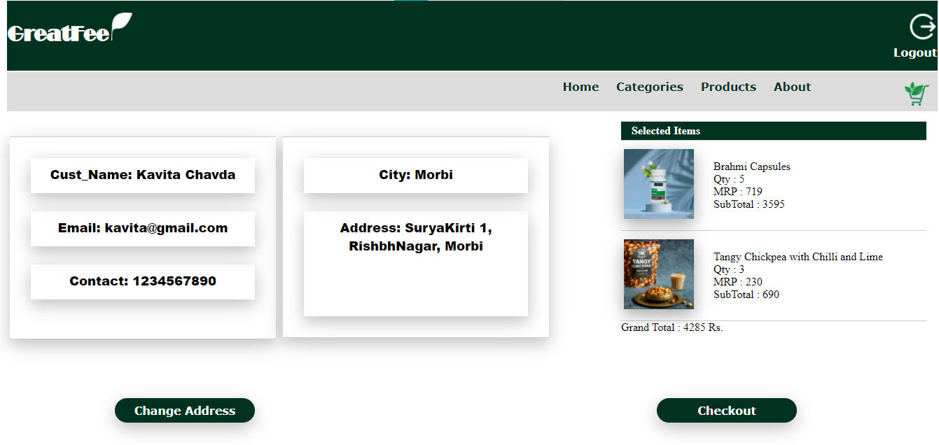

Change or Add Address

Description : This is page where user can change or add new address for shipping.

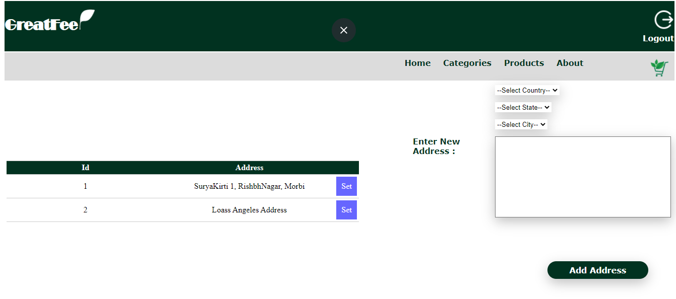

Admin Login

Description : This is Admin Login Page.

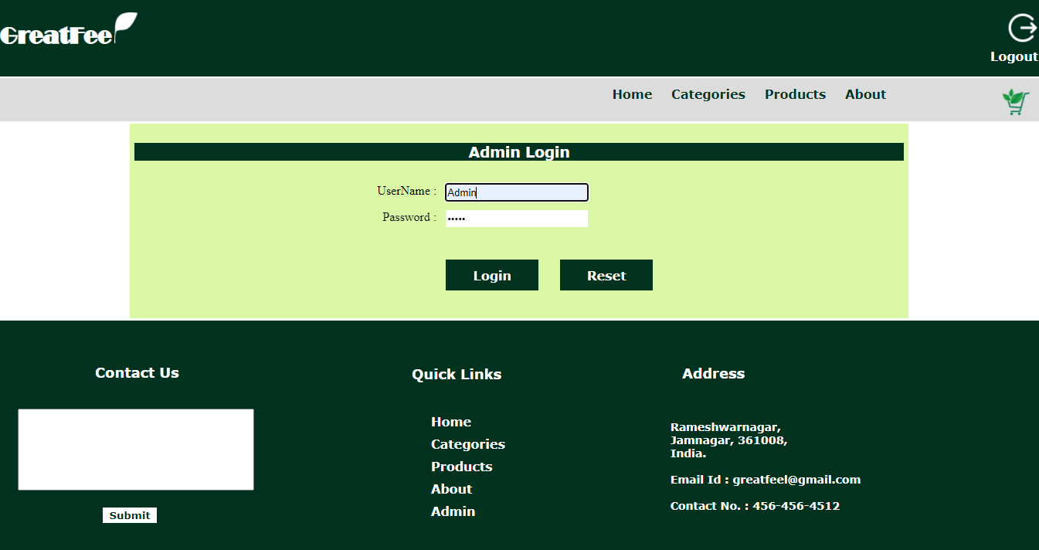

Invoice Page

Description : This Is Electronic Invoice which can be downloaded in pdf format by Customer.

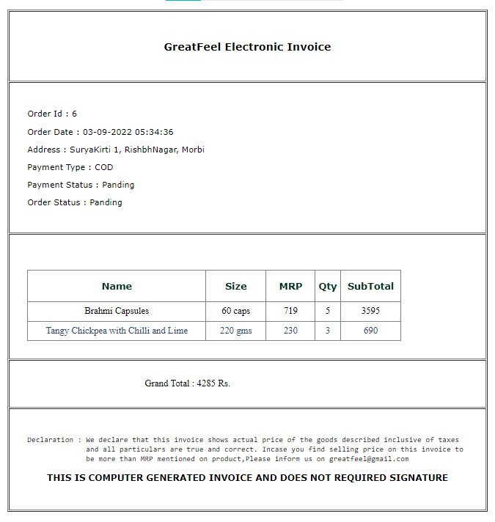

Category Master

Description : This is Category Master page where all Categories are Managed.

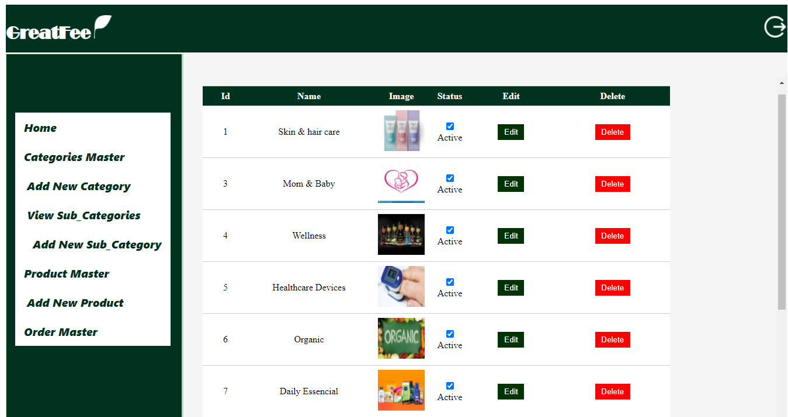

Add New Category

Description : This is Add New Category page where new Categories can be added.

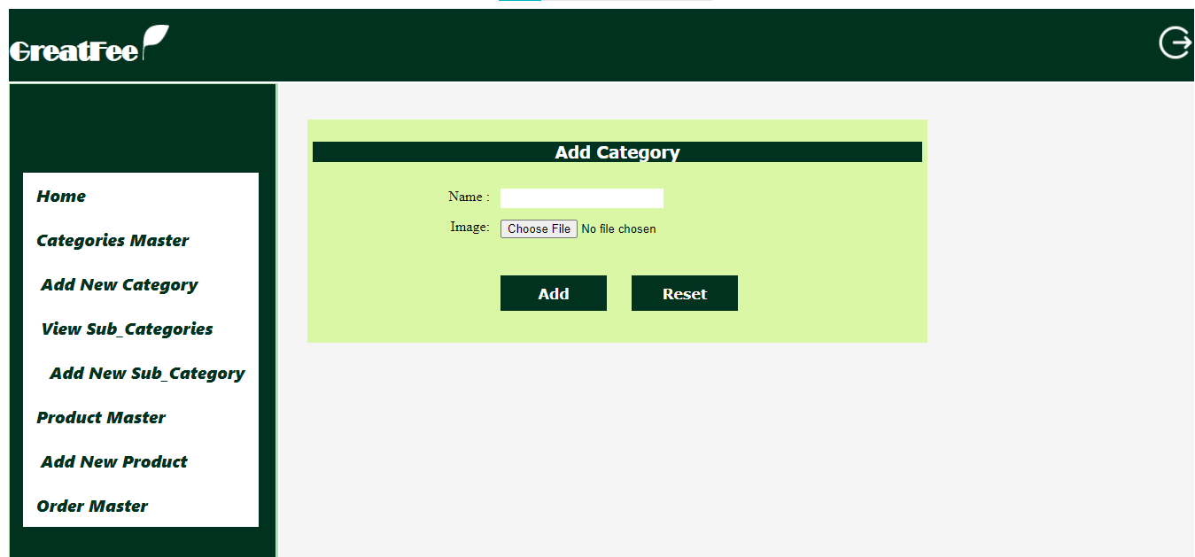

Sub Category Master

Description : This is Sub Category Master page where all Sub Categories are Managed.

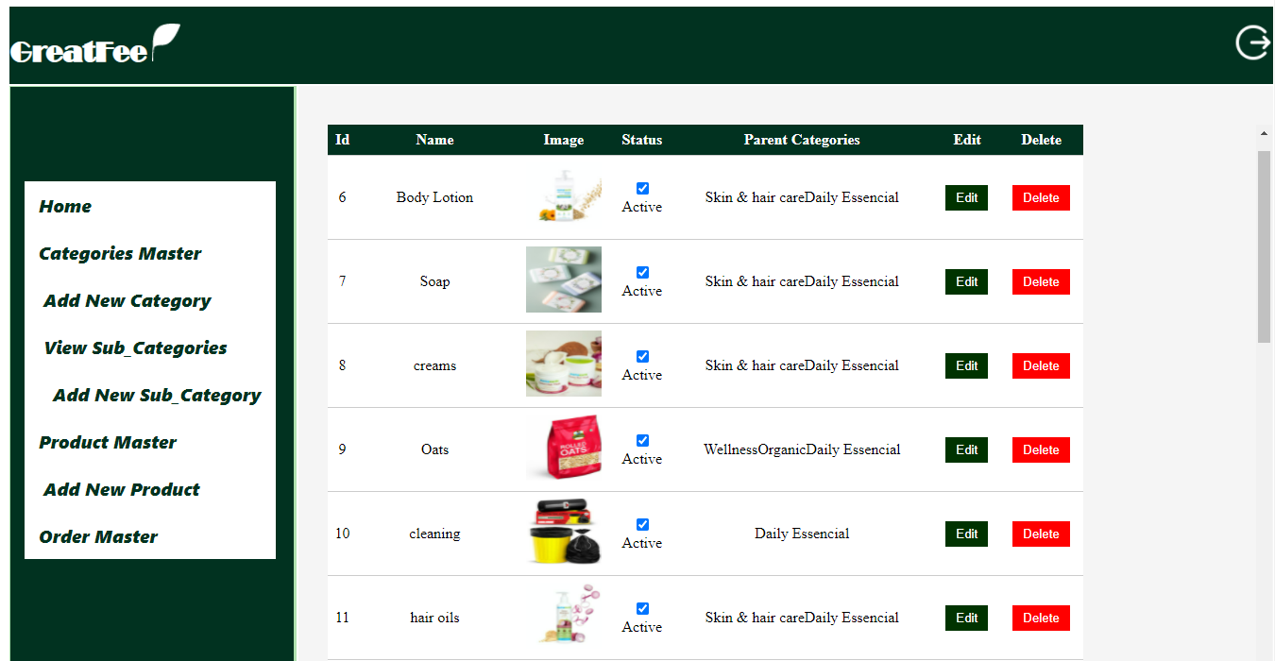

Add New Sub Category

Description : This is Add New Sub Category page where new Categories can be added.

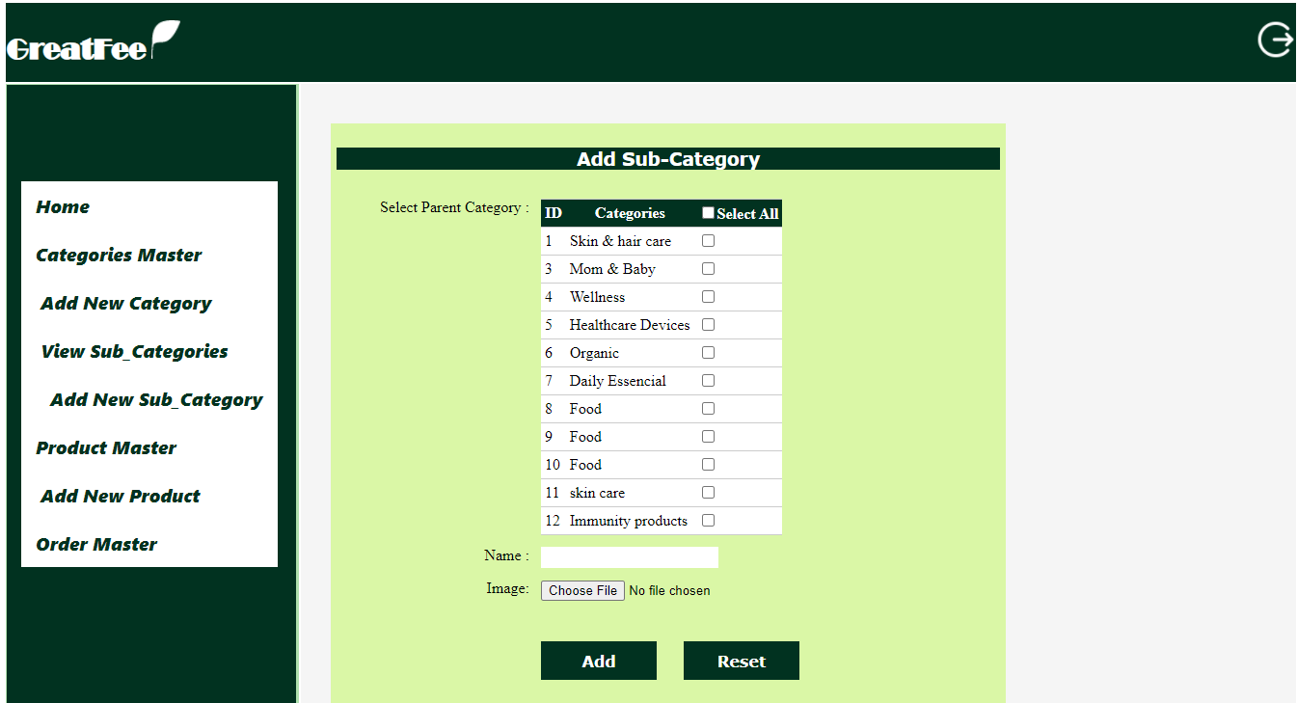

Product Master

Description : This is Product Master page where all Products are Managed.

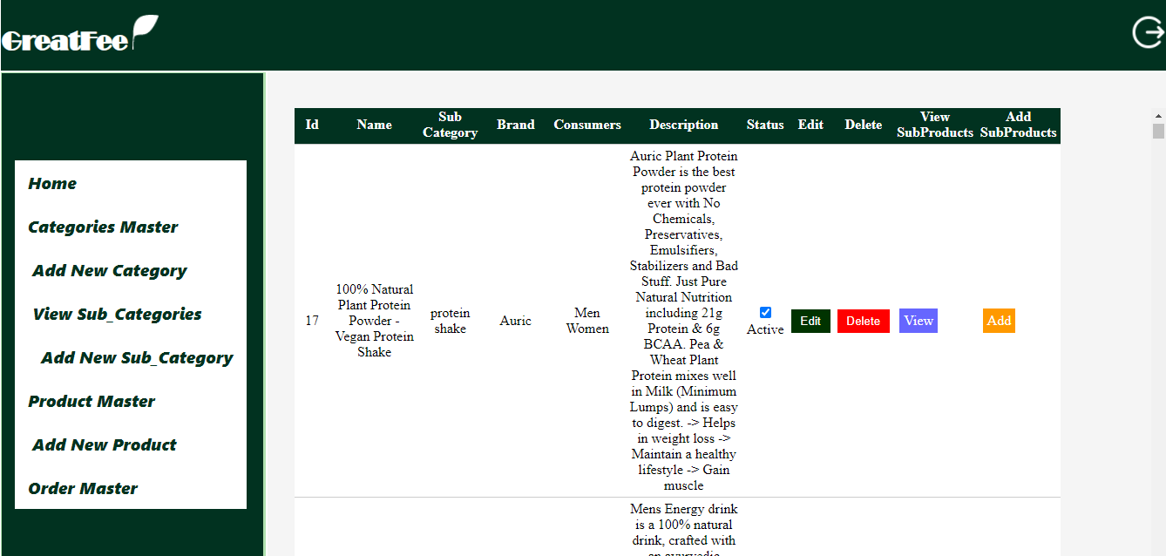

Add New Product

Description : This is Add New Product page where new Product can be added.

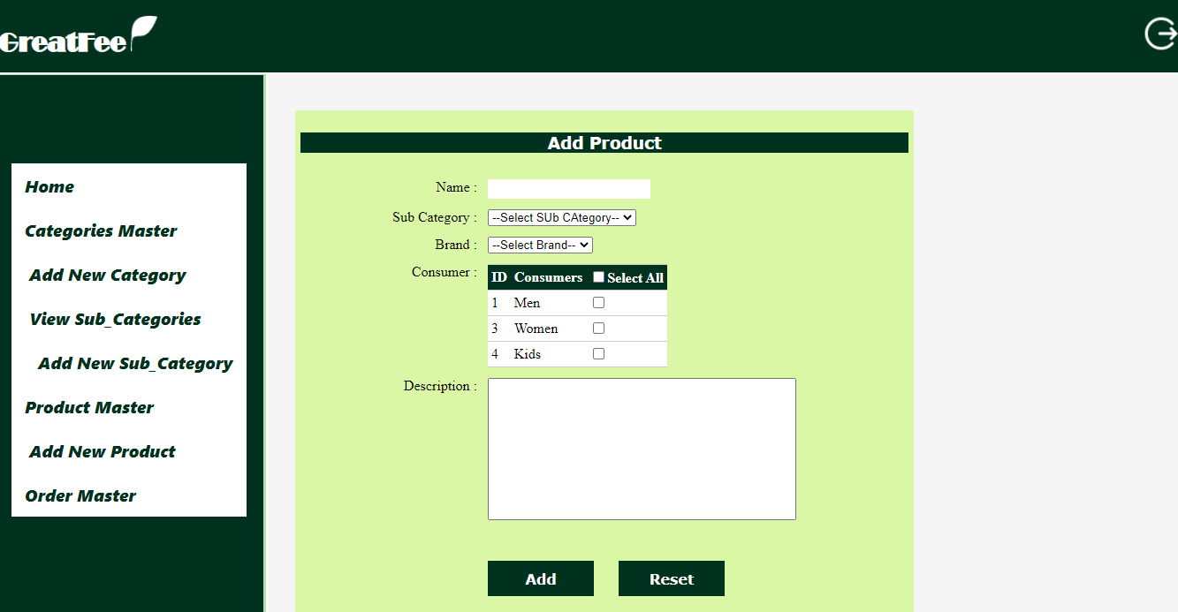

Sub Product Master

Description : This is Sub Products Master page where all Sub Products are Managed.

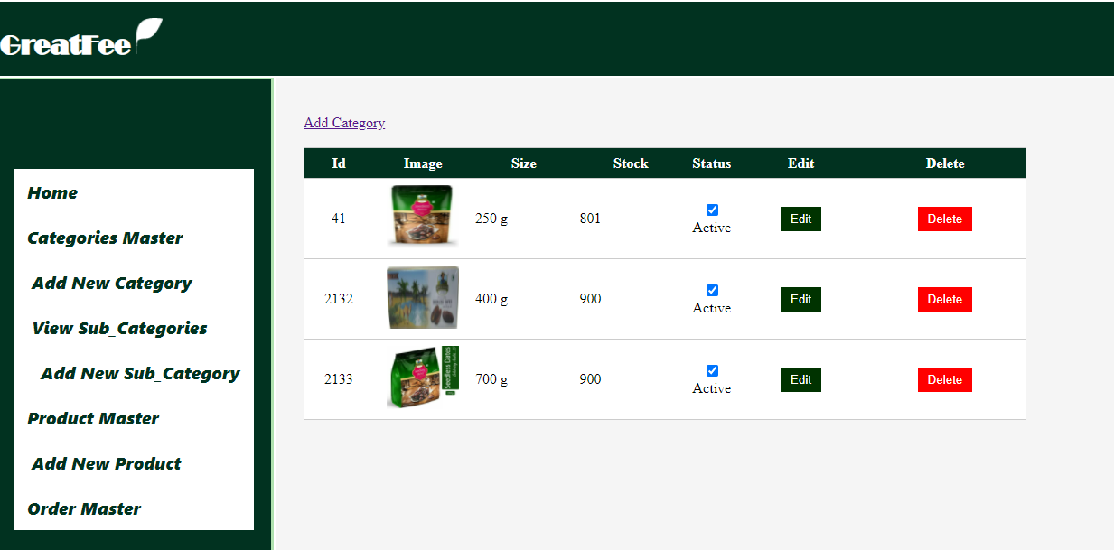

Add New Sub Product

Description : This is Add New Sub Product page where new Sub Product can be added.

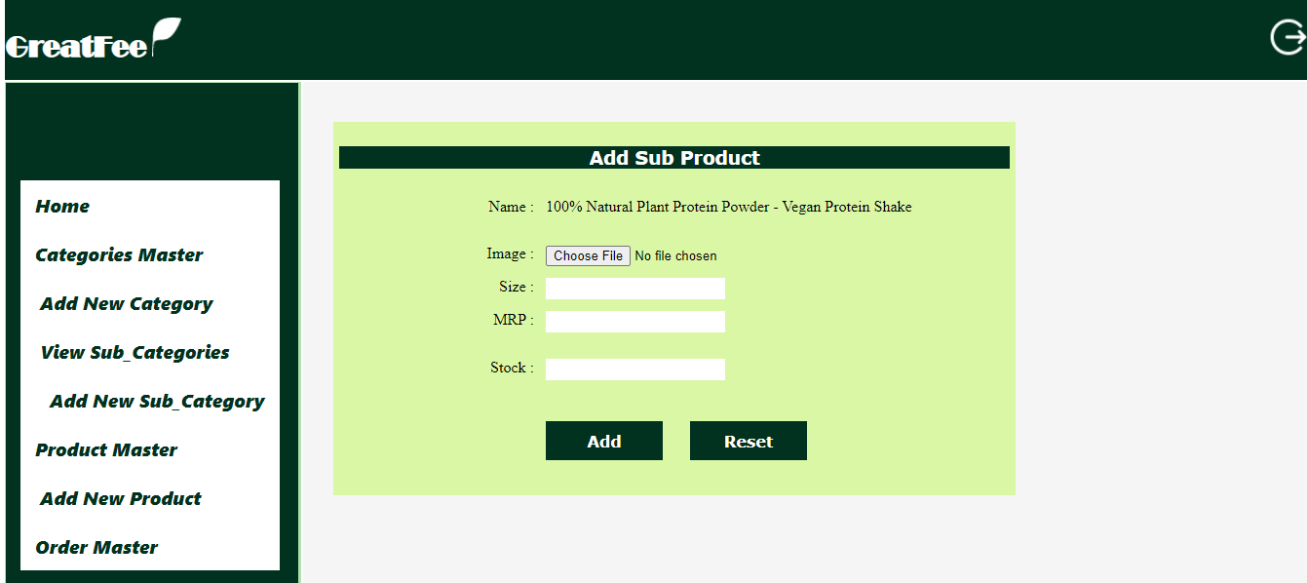

Order Master

Description : This is Order Master page where all Orders are Managed.

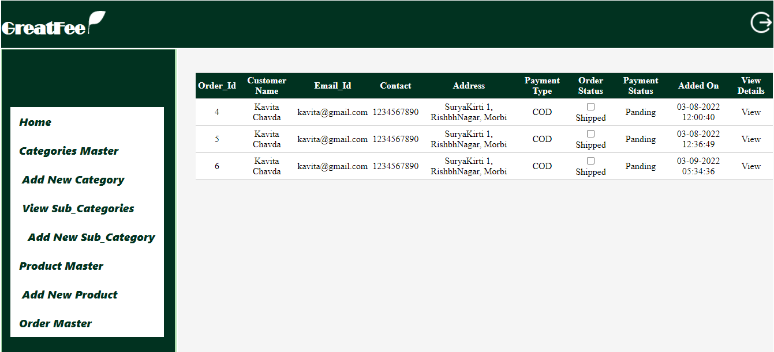

**Limitation & Future Enhancement**

* **Limitation :**
* This project does not provide facility of online payment method . so , smart card payment is not possible.
* Order live status can not be tracked in this project.
* Search criteria can not be saved.
* **Future Enhancement :**
* Product delivery tracking facility can be included.
* Smart card payment method can be applied.
* Search criteria can be saved.

**Bibliography**

* www.javatpoint.com
* www.C-sharpcorner.com
* www.microsoft.com
* www.W3schools.com